ClusterIP service definition example

Target port is the pod port

Port is the service port expose for the application cluster

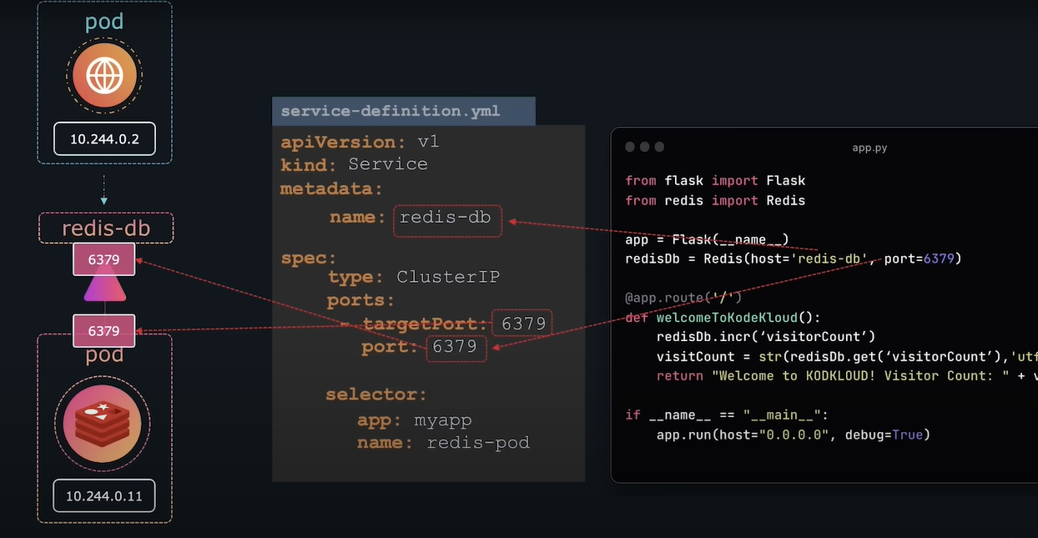

Node port example

Target port is used in Pod port

Port is the service port

Nodeport is the port of the node used to expose outside world

